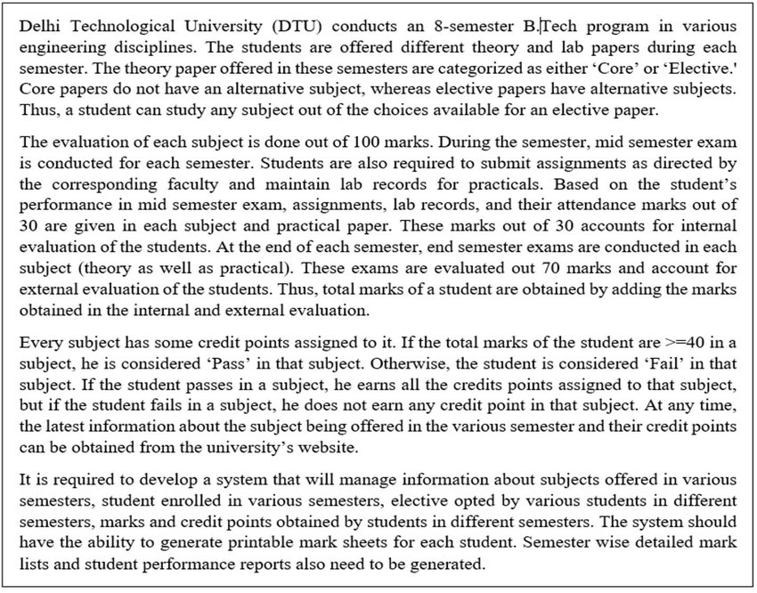

Problem statement for Result Management System as taken from case study